Title IN ENGLISH LANGUAGE
Name and SURNAME of the author – name and SURNAME of the author
- - - - - - - - - - - - - - - - - - - - - - - - - - - - - - - - - - - - - - - - - - - - - - - - - - - - - - - - - - - - - - -
ABSTRACT: Xxxxxx
Key words: xxxxxxx

introduction
The original scientific paper must not exceed 10 pages (in the journal paper template style) including references and appendices. The structure of the manuscripts must be as follows:

1 xxxxx
Xxxxxxxxxxxxxxxxxxxxxxxxxxxxxxxxxxxxxxxxxxxxxxxxxxxxxxxxxxxxxxxxxxxxxxxxxxxxxxxxxxxxxxxxxxxxxxxxxx.

(1)

r - vzdialenosť bodu izopachy od špičky trhliny [m]
a - rozmer trhliny [m]
θ - uhol izopachy v závislosti od r [˚]
σ - F/S - celkové napätie (zaťaženie) [MPa]
σ_{x}, σ_{y}, σ_{xy} - hlavné napätia v smere osi x, y, xy [MPa]

Xxxxxxxxxxxxxxxxxxxxxxxxxxxxxxxxxxxxxxxxxxxxxxxxxxxxxxxxxxxxxxxxxxxxxxxxxxxxxxxxxxxxxxxxxxxxxxxxxxx
Xxxxxxxxxxxxxxxxxx

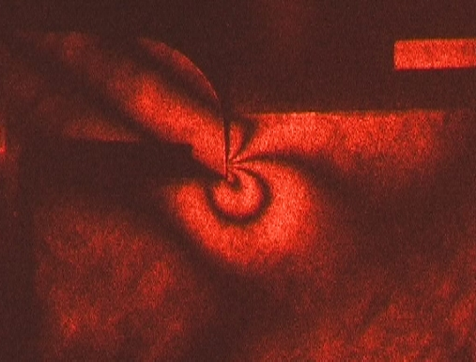

Figure 1 Xxxxxxx

Table1 Xxxxxxxx
Uhol Θ [˚] | 0 | 20 | 40 | 60 | 80 | 100 | 120 | 140 | 160 | 180
σ_{x} [MPa] | 0,131 | 0,105 | 0,075 | 0,042 | 0,035 | 0,044 | 0,062 | 0,065 | 0,039 | 0
σ_{y} [MPa] | 0,131 | 0,125 | 0,129 | 0,127 | 0,125 | 0,100 | 0,062 | 0,024 | 0,003 | 0
σ_{xy} [MPa] | 0 | 0,0174 | 0,0171 | 0 | -0,026 | -0,048 | -0,054 | -0,036 | -0,011 | 0

1.1 Xxxxxxx
Xxxxxxxxxxxxxxxxxxxxxxxxxxxxxxxxxxxxxxxxxxxxxxxxxxxxxxxxxxxxxxxxxxxxxxxxxxxxxxxxxxxxxxxxxxxx

REFERENCES

KUČERA, M., KOVÁČ, J., 2012. Degradácia olejových náplní v prevádzkových podmienkach. Zvolen: TU vo Zvolene. ISBN 978-80-228-2427-9.

Acknowledgement: Specify the number and name of the task if it is related to an article.

Contact address:
Name of first author with academic degree:, name of workplace, address of workplace, email
Name of first author with academic degree:, name of workplace, address of workplace, email

